OAPT Conference
Friday May 13, 2016
Opening Discussion Panel: Diverse Perspectives on Physics and STEM

Join us for the opening discussion panel on Friday May 13, 2016. The discussion panel hopes to create a thought provoking opening to the theme of this year’s conference! Let’s capture some diverse perspectives in STEM!

Dr. Paul Salvini
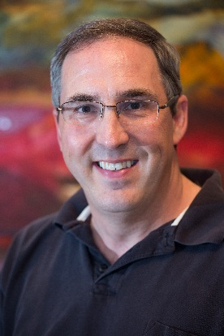
Paul Salvini is Chief Executive Officer of the Accelerator Centre, an award winning facility dedicated to helping start and scale technology-based businesses. He also holds appointments as Associate Vice President of Research Commercialization at the University of Waterloo and Adjunct Professor Computer Science at the University of Toronto. Paul is President of the University of Waterloo Alumni Council which represents the university’s 180,000 alumni in 145 countries. He is an active member of the community, a member of Barnraisers’ Council, and a director on multiple not-for-profit boards including THEMUSEUM and Centre In The Square. Prior to joining the Accelerator Centre, Paul held CTO positions at Christie Digital and at Side Effects Software. At Side Effects, he led a three-time Academy Award winning team of mathematicians and software developers in the development of 3D animation and visual effects software for the film industry -- used in over 500 Hollywood films. His research expertise is in computer simulation. He holds a BMath in Computer Science from the University of Waterloo, MASc and PhD degrees in engineering from the University of Toronto, and an MBA from the Rotman School of Management at the University of Toronto. In 2007, Dr. Salvini was named one of Canada’s Top 40 Under 40™, a national award that honors individuals for outstanding achievements in innovation, leadership, vision, and community involvement.

Dr. Shohini Ghose
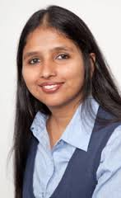
Shohini Ghose is an Associate Professor of Physics and Computer Science and Director of the Centre for Women in Science at Wilfrid Laurier University in Canada. She is a theoretical physicist who examines how the laws of quantum physics might be harnessed to transform computation and communication. She and her co-workers made the first-ever movies of cesium atoms demonstrating a connection between chaos theory and quantum entanglement. She is the recipient of several awards including a 2011 Sera Bengali award and a TED Fellowship in 2014. She is an Affiliate of the Perimeter Institute for Theoretical Physics and the Institute for Quantum Computing at the University of Waterloo, and a Fellow of the Balsillie School of International Affairs.

Ms. Cailin Clarke
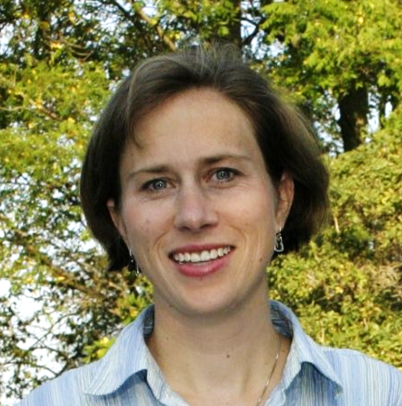
Let’s Talk Science is an award-winning, national, charitable organization focused on education and outreach to support youth development. We create and deliver unique learning programs and services that engage children, youth and educators in science, technology, engineering and mathematics (STEM).

Cailin Clarke is the Director of Planning and Organizational Development for Let’s Talk Science. Her role involves planning oversight, organizational development, the Operations Committee and strategic lead for a number of cross-organizational programs and First Nations Métis and Inuit initiatives. She is a qualified teacher and has a great deal of experience in not-for-profit management. Prior to joining Let’s Talk Science, Cailin worked for the Maitland Valley Conservation Authority in communications and environmental education.
Cailin has had responsibility for a number of different areas at Let’s Talk Science including directing research and new program development, managing professional learning programs, business development and evaluation. She has presented at numerous conferences on behalf of Let’s Talk Science and is a contributor on several research publications.
Cailin has been a volunteer in her community as a Guiding leader and also as a soccer coach. In 2009, she was awarded the Dr. Bertha Wolfe award for her contributions as President of a local Board of Directors and in 2015 she was the recipient of an Ontario volunteer service award from the Government of Ontario for continuous years of service.

Ms. Nicole Barucha
Nicole Barucha is a student at Western University, finishing up her second year. She is currently in the process of completing an honors double major degree in medical physics and computer science. In addition to academics, Nicole is involved in numerous extra-curricular activities, including being a department representative on the Faculty Student Council and a member of her sorority’s executive and chapter council. In the future, Ms. Barucha hopes to have a career that combines her knowledge of computer science and medical physics. She aspires to complete graduate studies in medical physics or a similar STEM field.

